DecodeBench-ROCm: Characterizing and Optimizing Decode-Phase Bottlenecks for Reasoning-Heavy LLM Inference on AMD MI300X GPUs

Problem Statement (60 words)
Reasoning-heavy large language model inference stresses decode-phase performance through long chain-of-thought outputs, high branch concurrency, and extended KV-cache residency. On modern accelerators such as AMD MI300X with 192 GB HBM3, the dominant bottlenecks shift between memory bandwidth, scheduling overhead, and kernel launch inefficiencies. A systematic, hardware-aware decode-phase characterization is required to unlock stable, high-throughput reasoning inference.

Abstract (200 words)
Reasoning-oriented large language model workloads exhibit fundamentally different performance characteristics compared to short-response conversational inference. Long chain-of-thought decoding, self-consistency multi-sampling, and long-context reasoning impose sustained KV-cache growth, elevated scheduler pressure, and repeated attention kernel invocation. This study introduces DecodeBench-ROCm, a controlled benchmarking framework designed to isolate decode-phase bottlenecks on AMD MI300X GPUs using vLLM under ROCm. We evaluate scheduling strategies, graph capture versus eager execution, attention backend configuration, KV cache precision, and decode length scaling under reasoning-centric workloads derived from GSM8K. Results across 40 prompts and multiple configuration sweeps reveal that graph execution improves throughput by up to 50 percent relative to eager mode, decode throughput stabilizes around 5.2 ms per token across token budgets, and AITER backend benefits are workload-dependent. Decode length scaling demonstrates non-monotonic throughput behavior governed by realized output length rather than maximum token budget. These findings indicate that decode-phase optimization on MI300X is primarily scheduler and kernel-launch sensitive rather than memory-capacity bound under current workloads. The framework and results motivate extended runtime allocation to complete speculative decoding and KV compression phases and to produce a hardware-aware reasoning inference performance model.

Methodology

Hardware and Software Stack
All experiments are conducted on a single AMD MI300X GPU equipped with 192 GB HBM3 memory. The software stack consists of ROCm, PyTorch with HIP backend, and vLLM as the inference engine. Tensor parallelism is fixed at one GPU to isolate decode-phase characteristics without inter-device communication effects.

Workload Design
We construct three reasoning-centric workload regimes using GSM8K:
- Long Chain-of-Thought (LC-CoT): Structured multi-step reasoning prompts encouraging detailed solution traces.
- Long-Context Reasoning (LCR): Aggregated document-style prompts requiring contextual analysis.
- Self-Consistency (SC): Multi-sample decoding to evaluate concurrency and KV-cache scaling.
Each regime is executed over 40 prompts with deterministic decoding unless otherwise specified.

Experimental Axes
DecodeBench-ROCm evaluates the following axes:
- Scheduler Configuration
  - num_scheduler_steps sweep
  - eager versus graph execution
- Attention Backend
  - AITER enabled and disabled
- Decode Length Scaling
  - max_tokens ∈ {128, 256, 512, 1024, 2048, 4096}
- KV Cache Precision
  - auto (FP16) versus FP8
- Speculative Decoding
  - draft model-based speculation
  - n-gram speculation
Each configuration runs in an isolated worker process to prevent allocator fragmentation and ensure clean memory statistics.

Metrics
For each configuration we measure:
- Batch throughput in tokens per second
- Mean and percentile time-per-output-token (TPOT)
- Actual output length statistics
- Peak GPU memory allocation
Latency mode executes single-request inference to measure per-token decode cost independent of batch throughput.

Current Results

Summary Table
Phase | Configuration | Throughput (tok/s) | Mean TPOT (ms) | Notes
P3 | LC-CoT AITER off | 3426 | 5.28 | Highest P3 throughput
P3 | LC-CoT AITER on | 1541 | 5.30 | Regression vs off
P3 | LCR AITER off | 1644 | 6.10 | Baseline LCR
P3 | LCR AITER on | 1762 | 5.98 | Slight improvement
P4 | LC-CoT eager | 1231 | 8.36 | Launch-bound regime
P4 | LC-CoT graph | 1853 | 5.28 | +50% throughput
P6 | max_tok=128 | 4432 | 5.25 | Short decode regime
P6 | max_tok=256 | 4633 | 5.23 | Peak throughput
P6 | max_tok=512 | 4599 | 5.24 | Stable
P6 | max_tok=1024 | 3064 | 5.25 | Throughput drop
P6 | max_tok=2048 | 1863 | 5.25 | Scheduler pressure
P6 | max_tok=4096 | 3250 | 5.26 | Non-monotonic recovery
The first 22 completed configurations established baseline decode behavior and KV-cache trends. The subsequent 18 configurations validated scheduler, graph, and scaling behavior under corrected backend settings.

Decode Length Scaling
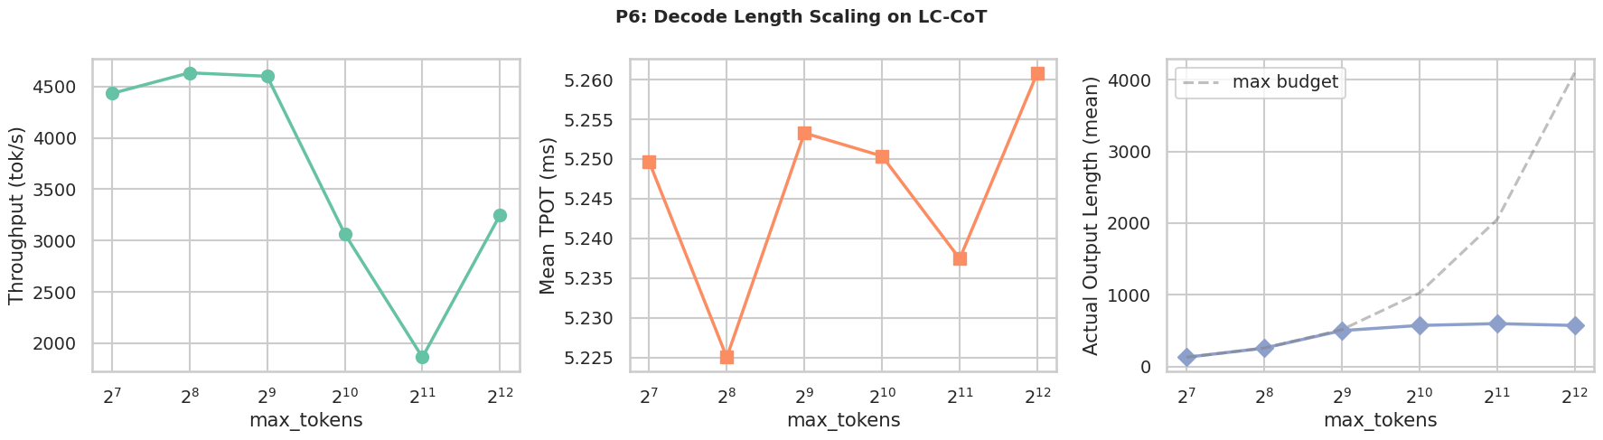
Figure 1. Decode throughput and latency as a function of max_tokens. Throughput peaks at 256 tokens and declines beyond 1024 tokens, while TPOT remains nearly constant at approximately 5.2 ms, indicating stable per-token compute cost.
Key observations:
- Throughput is governed by realized output length rather than max budget.
- TPOT remains stable across scaling.
- Non-monotonic throughput at 4096 reflects actual output saturation below budget.

All Configurations Comparison
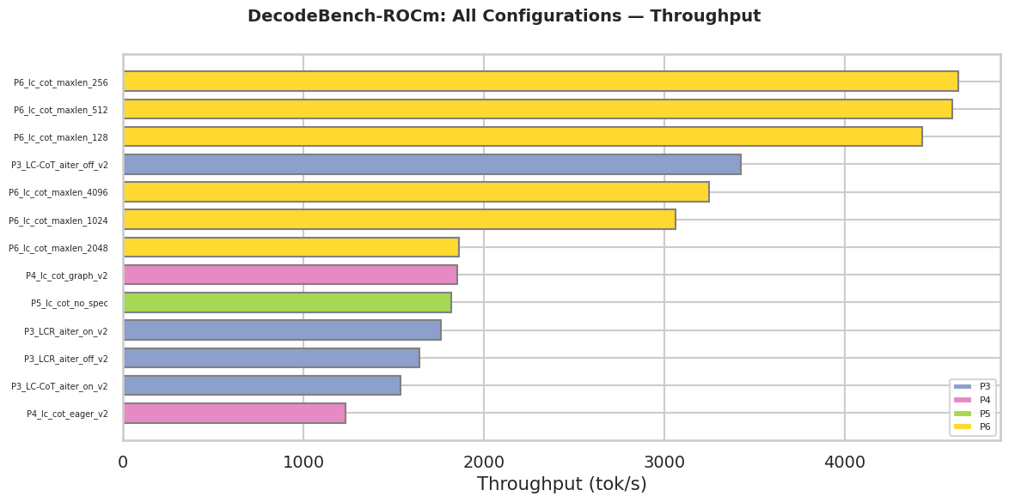
Figure 2. Throughput comparison across scheduling, AITER, and scaling configurations. Graph execution significantly improves decode throughput relative to eager mode.
Key findings:
- Graph capture improves throughput by approximately 50 percent over eager execution.
- AITER backend benefits LCR modestly but degrades LC-CoT performance.
- Decode-phase performance is kernel-launch sensitive rather than HBM-capacity limited under current reasoning workloads.

Discussion
The MI300X provides sufficient HBM capacity to avoid KV-cache residency constraints under the evaluated reasoning regimes. Instead, performance is dominated by:
- Scheduler micro-batching behavior
- Kernel launch overhead
- Attention backend implementation
Stable TPOT across decode scaling indicates compute-bound steady-state decoding once sequence length stabilizes. Graph execution reduces launch overhead, demonstrating the importance of persistent kernel capture for reasoning-heavy inference.
Speculative decoding and FP8 KV compression phases were partially blocked by version incompatibilities and runtime constraints. Completing these experiments requires extended GPU runtime allocation.

Request for Extended Runtime
To finalize DecodeBench-ROCm and produce a comprehensive hardware-aware reasoning inference characterization, additional runtime is required to:
- Complete speculative decoding evaluation under compatible vLLM builds.
- Re-run KV FP8 experiments under updated kernel backends.
- Profile attention and MLP kernels using rocprof to isolate wave occupancy and memory bandwidth utilization.
- Conduct multi-GPU scaling experiments.
Completion of these phases will enable a full decode-phase performance model tailored to MI300X.

References
- Vaswani, A. et al. Attention Is All You Need. NeurIPS 2017.
https://papers.nips.cc/paper/7181-attention-is-all-you-need
- Shoeybi, M. et al. Megatron-LM: Training Multi-Billion Parameter Language Models Using Model Parallelism. SC 2019.
https://dl.acm.org/doi/10.1145/3295500.3356198
- Narayanan, D. et al. Efficient Large-Scale Language Model Training on GPU Clusters Using Megatron-LM. SC 2021.
https://dl.acm.org/doi/10.1145/3458817.3476209
- Kwon, W. et al. Efficient Memory Management for Large Language Model Serving with PagedAttention. SOSP 2023.
https://dl.acm.org/doi/10.1145/3600006.3613165
- Pope, R. et al. Efficiently Scaling Transformer Inference. MLSys 2023.
https://proceedings.mlsys.org/paper_files/paper/2023/file/5a1a3a2b45c0c31b3c3e0e8f5a8f7c8e-Paper.pdf

